Dr. Emily Driggers

**our principal** driggem[@boe.richmond.k12.ga.us](mailto:tudorch@boe.richmond.k12.ga.us)

school

and community

**our students**



A.R. Johnson Health Professions High School was established during the 1980-81 school year as a pilot program using federal government funds from a Magnet Implementation/Planning Grant. In 1984 the feasibility of adding an engineering program at A.R. Johnson was studied and in 1985 the engineering program was introduced, increasing program diversity and interest in the school.

Consistently recognized by community, state, and nation as one of the top performing high schools in Georgia, Augustus Roberson Johnson Health Science and Engineering Magnet School has edu- cated some of our nation’s most distinguished engineers and medical professionals. A.R. Johnson is located in Augusta which is the second largest and oldest city in Georgia. Augusta is best known as the Garden City and home of the Masters Golf Tournament. RCSS operates 54 schools and serves over 30,000 students. RCSS has International Baccalaureate Programs, top-rated magnet schools and programs, specialized curricula such as STEM (Science, Technology, Engineering and Mathematics) and Arts Infusion, and Technology rich classrooms.

666 enrolled

AP honors, awards & recognitions

# Special Programs

Health Science and Engineering Magnet School (STEM Program), Biology, Calculus, Chemistry, English Language Arts and Composition, English Literature and Composi- tion, Government, Statistics, US History, Engineering & Technology, Engineering Draft- ing & Design, Therapeutic Services: Dental, Therapeutic Services: Pharmacy, Health Information Technology, Therapeutic Services: Patient Care, Choral, Art Orchestra, Spanish, Latin, Augusta University Confucius Institute Cultural Collaboration, STEM School Health Sciences and Engineering

* AP Challenge School

Our 2022 CCRPI Stats

* AP Access and Support School
* Recognized by National Magnet Schools of America as Magnet School of Distinction
* Governor’s Annual Platinum Award for Schools Meeting and Exceeding Standards
* Awarded Silver Medal in 2001 by US New World Report
* Recognized by Gates Millennium Scholarship Program
* Awarded as one of Georgia’s School of Excellence in Student Achievement

College and Career Ready Performance Index (CCRPI) is Georgia’s statewide accountability sys- tem. The CCRPI assesses how well students are prepared for college and careers and ensures that schools are focused on improving achievement among all students. The index measures progress on indicators such as content mastery, student attendance, and graduation rate. Schools earn CCRPI points based on indicators that vary by grade and school level and align with measures of college- and career-readiness. Schools may earn up to a set number of points in five main catego- ries, for a total of 100 possible points.

|  |  |  |  |
| --- | --- | --- | --- |
| **graduation rate** 100  **average daily attendance** 97.12 | | | School Hours: 8:15am—3:25pm  Assistant  Superintendent: Dr. Donald Mason  Superintendent: Dr. Kenneth Bradshaw |
| class rank & grade point average | An official class rank is compiled for each grade that is computed at the end of the year. Averages are carried out to three decimal places and final averages are not rounded. Student’s grade point average (GPA) is based on quality points. Regular high school courses are on a  4.0 scale and Advanced Placement, International Bacca- laureate, and College/University courses are on a 5.0 scale awarded for each grade earned. High school stu- dent transcripts include the GPA, class rank, and numeri- cal average. | | Accredited in 2017-2018 |
| quality points | | graduation requirements | |

**Regular Classes**

**A = 4.0**

**B = 3.0**

**C = 2.0**

**D = 1.0**

**F = 0**

**AP & IB Classes**

**A = 5.0**

**B = 4.0**

**C = 3.0**

**D = 2.0**

**F = 0**

grading system

**A (90-100)**

**B (89-80)**

**C (79-75)**

**D (74-70)**

**4 ELA**

**4 Mathematics**

**4 Science**

**3 Social Studies**

**1 Health/PE**

**3 CTAE/Fine Arts/Foreign Lan- guage/JROTC**

**4 Electives**

**23 Total Units**

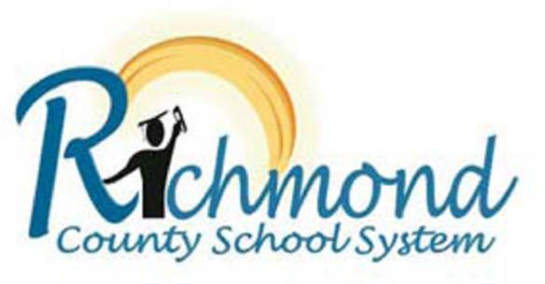**F (below 70)**